### PROGRAM INFORMATION

Our program runs for four sessions in July, Monday-Thursdays beginning on

Session 1:July 9th-12th

Session 2:July16th- 19th

Session 3:July 23rd-26th

Session 4:July 30th-Aug 2nd

Ages 4-11 years old

The program runs from 9-2:30

Come for one 4-day session or take advantage of all we have to offer by enrolling in all four!

**NEW THIS YEAR!**

**ADVENTURE/NATURE EDUCATION WEEK**

**July 30-August 2 9-2:30**

**For the older child ages 11-14, more challenging activities and projects, hikes, education and hands on learning –for the future counselors in training!**

Low child to instructor ratio

Staff includes certified teachers and trained volunteers

## IMPORTANT DATES AND PAYMENT INFORMATION

In an effort to secure your child’s spot, please return this form with a $100 deposit per session or payment in full as soon as possible. Remaining balance is due by May 17th, 2018. Do not hesitate to call with questions about enrollment/availability or about our program. Please send payment and registration form to the following address:

**Summer Fun at the Farm**

**The Youth Enrichment Center**

**Hilton-Winn Farm**

**189 Ogunquit Road**

**Cape Neddick, ME 03902**

**207-361-1385**

[**www.hilton-winnfarm.org**](http://www.hilton-winnfarm.org)

**nbreen@hilton-winnfarm.org**

**501(c)(3) nonprofit corporation**

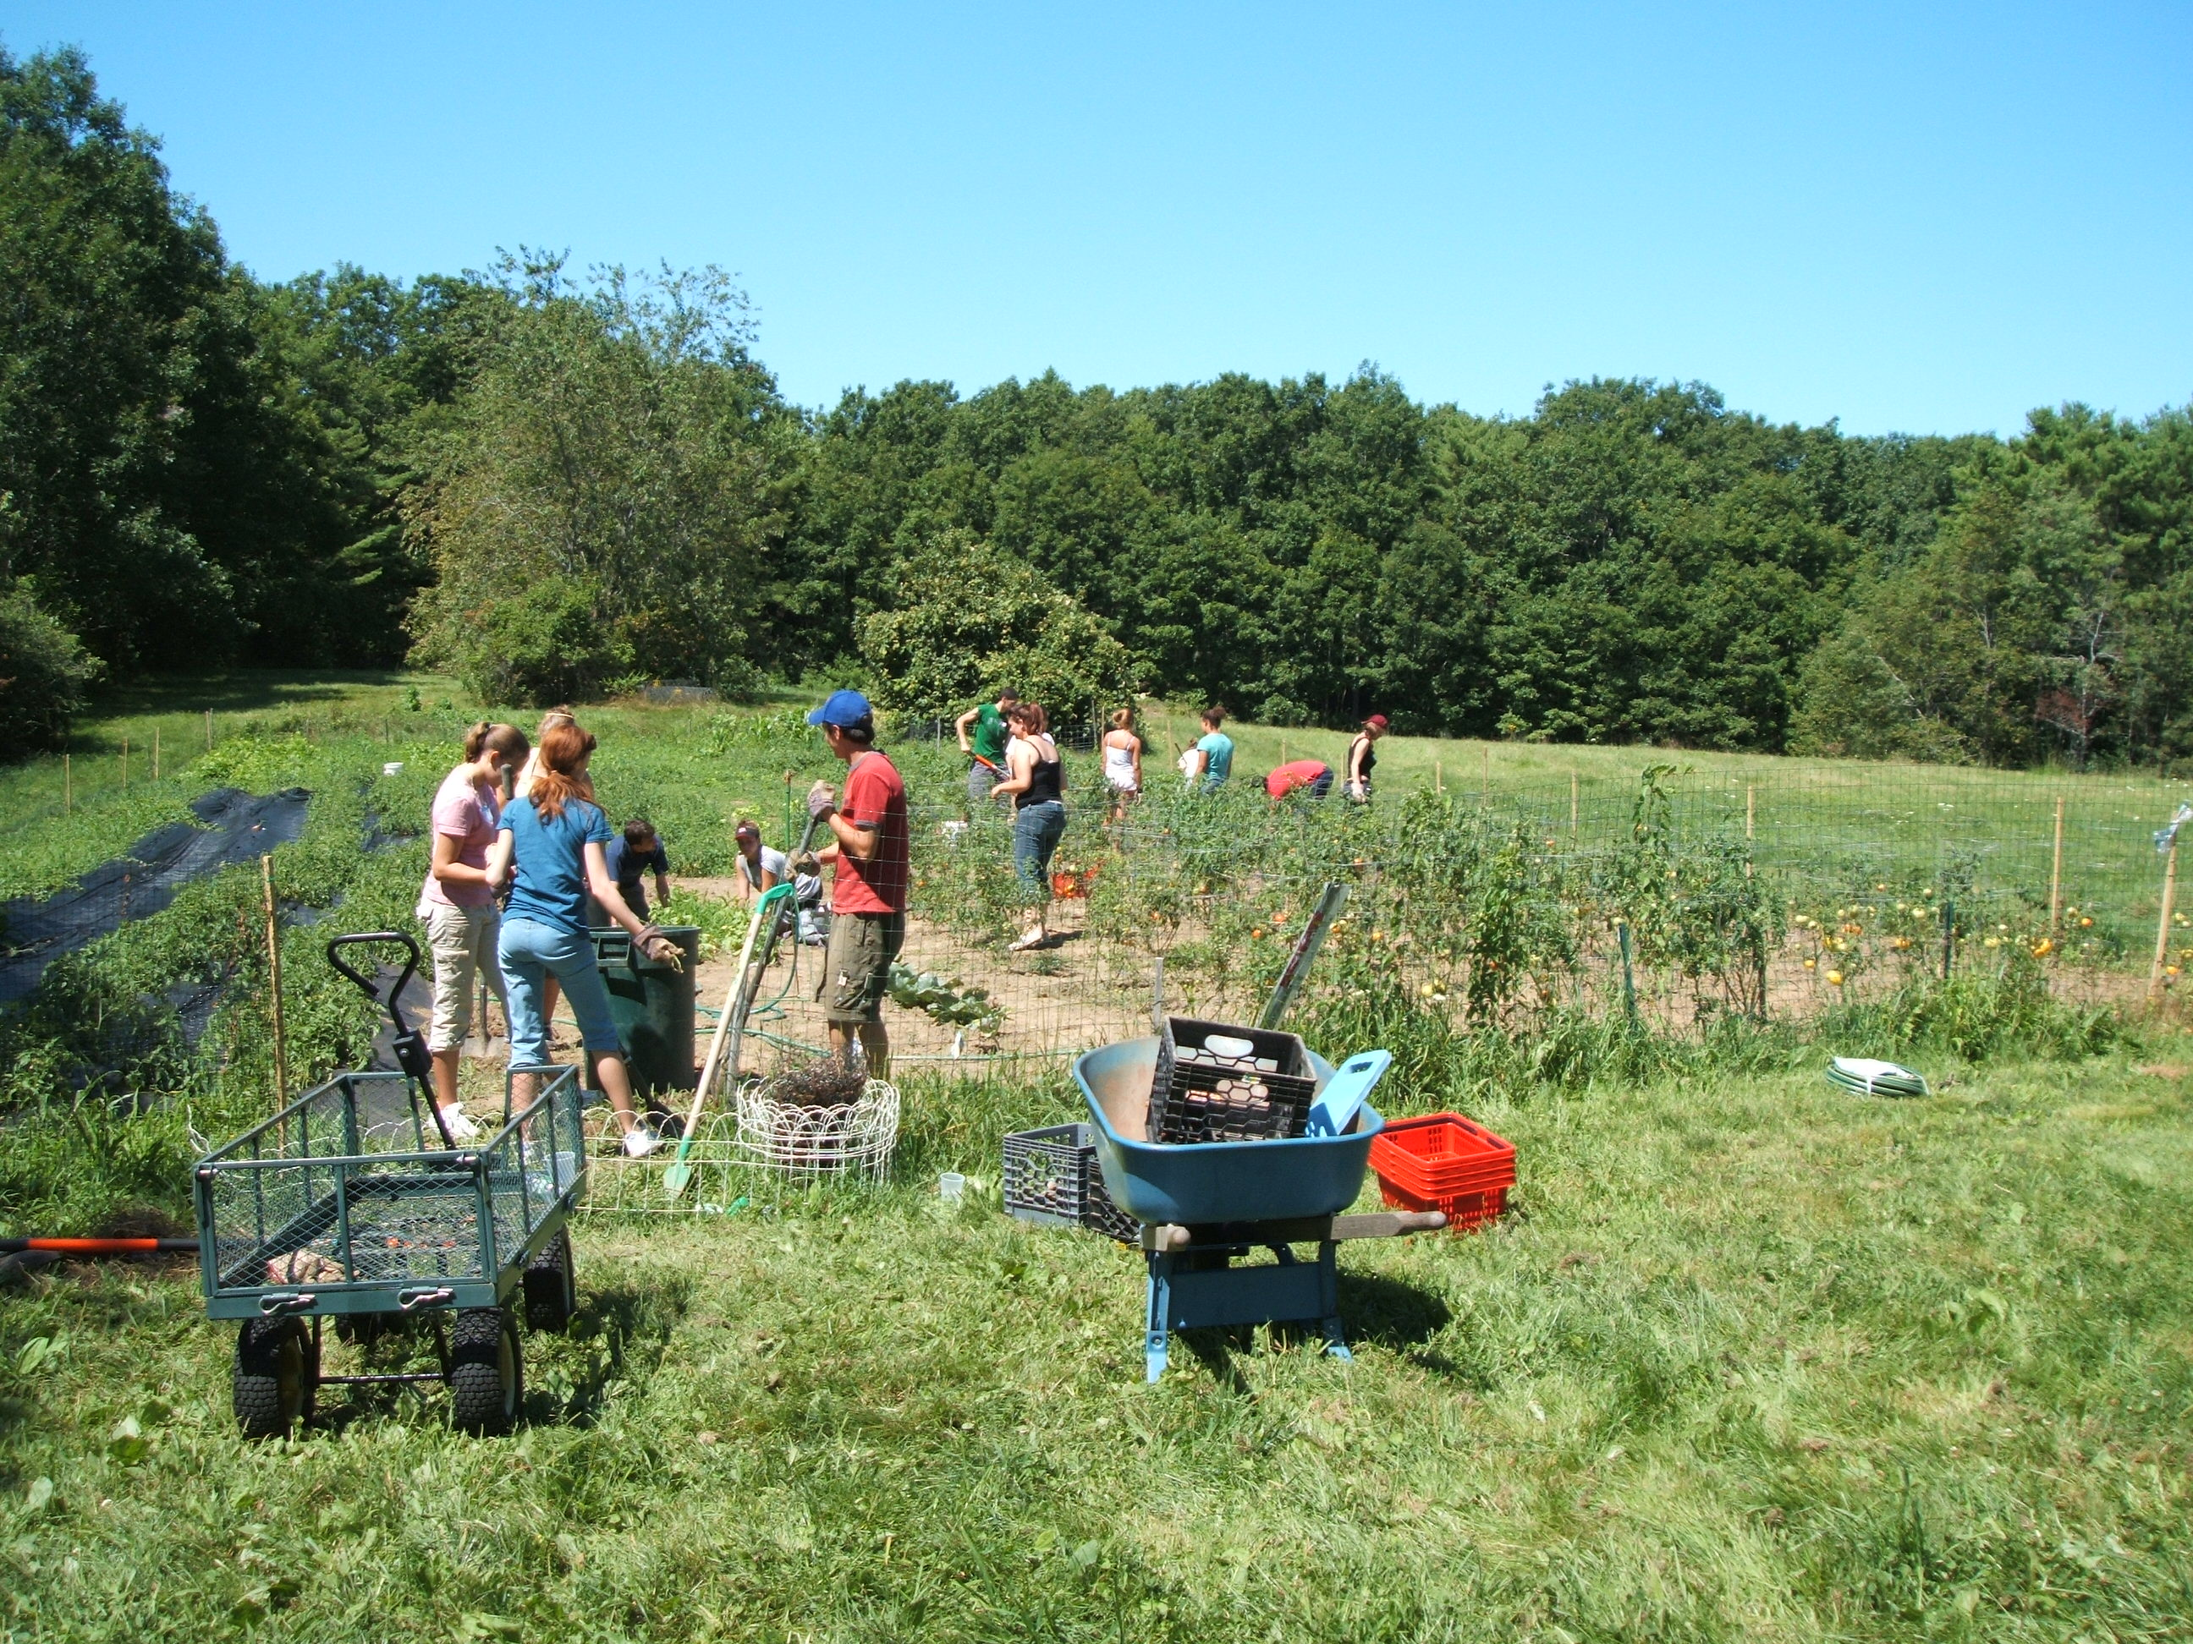

A weekly summer nature-based activity program at the beautiful Hilton-Winn Farm in Cape Neddick, Maine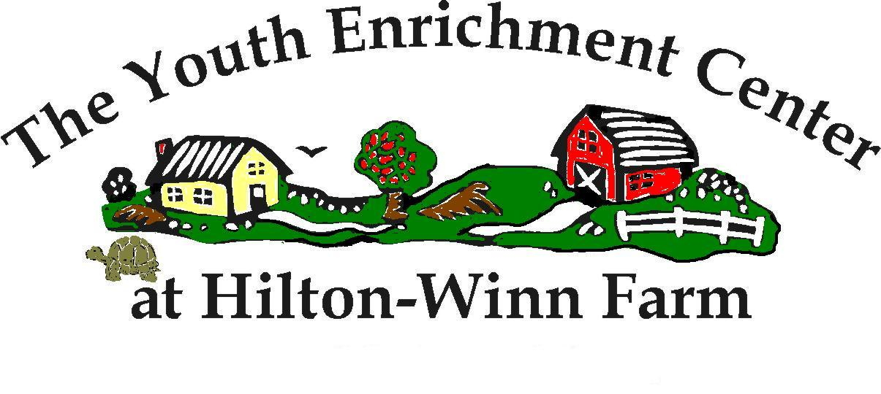

SUMMER FUN

at the

FARM



Unplug at the Hilton-Winn Farm and Connect to Nature !!

# Give your child a country farm experience that will enrich their hearts, minds and spirits while they have FUN!

# Give your child an awesome, fun-filled nature experience this summer!

Nancy Breen is the Director of the Youth Enrichment Center (YEC) at the Hilton-Winn Farm, and holds a degree in Early Childhood Education from Colby-Sawyer College. In 2002, she purchased the beautiful property in order to establish a place where children could experience nature and participate in farm-based educational activities. Included in our enthusiastic, qualified staff :

* Program Director Eva Diharce, Speech and Language Pathologist
* Barbara Early , Retired Educator
* Jackie Mait, Head counselor
* Gabrielle Bertrand , 5th grade teacher
* Other quality , experienced leaders with a love of nature and children
* Local specialists ( educators, environmentalist, artists, musicians, bee keeper etc…)

YEC programs are aimed at fostering growth in teamwork, communication, tolerance, and self-esteem building.

The Farm provides the ultimate natural setting for this magical experience. 48 acres of fields and forest surrounded by 300 acres of conservation land offer both a safe, beautiful setting and a wonderful space in which to grow.

The goal of the Summer Fun program is to use our surroundings to convey the importance of nature and our environment. This will be done through carefully planned activities and projects that build upon creativity and teamwork and are just plain FUN !!!!

Program Details

Each session will follow the same outline, but activities and events will change. This will allow for children attending multiple sessions to enjoy varied experiences.

The first day will include an introduction to the farm, guidelines and expectations. There will be getting-to-know each other activities and introductions. We will familiarize the children with their new surroundings. Children will create a hand-made journal to be used for activities during the week, and jump right into some of the great nature-based activities we have planned including:

* Daily nature hike
* Gardening (planting, harvesting & weeding)
* Farm Animal Care
* Special presentations from visiting guests
* Scavenger hunts
* Nature crafts (including prints from nature, leaf rubbings, making natural dyes).
* Animal tracking
* Learn to identify plants, birds & wildlife
* Fairy houses/Toad Abodes
* Exploring surrounding fields & forests.
* Implementing & education of composting and recycling
* Daily Yoga
* Practicing and experiencing being “un-plugged “ in nature and “mindfulness” activities

Snacks, lunch and drinks are provided each day with active participation from the children. We have a wonderful garden that offers nutritious, healthy produce daily. We strive to provide wholesome and fulfilling foods to nourish the body and soul, as well as food that your kids will want to eat. The farm-to-table example provided each day is an invaluable lesson. We are well-versed in food allergies and any needed accommodations can be easily made.

Registration

Name:________________________

Gender:________ Age:__________

Child’s Address:_______________

Town/State/Zip:________________

Cell Phone:___________________

Parent’s/Guardian’s names:_________

____________________________

Work/home Phone:______________

The child lives with:

__both Parents __Mother

__Father __Other

Please check the appropriate session:

July 9th– July 12th __________

July 16th– July 19 th __________

July 23rd – July 26th __________

July 30th-Aug 2nd ___________

**Adventure week ages 11-14,**

**July 30th-Aug 2nd ___________**

The cost for each session is $275

The cost for each individual day is $65

T-shirt size: YS ,YM, YL, AS, AM, AL

